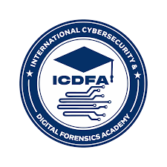
INTERNATIONAL CYBERSECURITY AND DIGITAL FORENSICS ACADEMY

ASSIGNMENT

Assignment Title: Advanced Linux Command Line For Digital Forensics
Student Name: Ahmad Zubairu Garba
Student ID: 2025/FWSD/11463
Course Title: Basic Computer Skills for Digital Forensics
Course Code: SBT-DF201
Instructor: Aminu Idris

August 16th , 2026
EXECUTIVE SUMMARY

This comprehensive report documents all findings, command logs, verification steps, and execution outputs from the hands-on digital forensics laboratory exercises. The sessions covered advanced Linux command-line operations, standard stream file descriptor manipulation (`stdin`, `stdout`, `stderr`), baseline environment documentation, cryptographic hash generation (`SHA256` and `MD5`), and controlled cross-platform evidence transfers utilizing `ncat` and `dd` between Kali Linux and Windows hosts. All procedures adhered strictly to authorized forensic safety boundaries and data integrity verification protocols.

Lab Environment

Machine 1 (Source): Kali Linux Virtual Machine (‘hostname: kali’, IP: 192.168.88.131)
Machine 2 (Target): Windows Host / PowerShell (VMnet1 IP: 192.168.202.1, VMnet8 IP: 192.168.88.1)
Network Setup: Isolated internal VM network enabling bidirectional TCP communication and successful ICMP connectivity
Tools Used: bash, cat, echo, ls, ip, ping, tee, ncat (Nmap suite), Windows PowerShell, certutil, dd, sha256sum

PROCEDURE & STEP-BY-STEP IMPLEMENTATION
Directory Structure Setup
The workspace directory hierarchy was initialized on Kali Linux to organize logs, evidence notes, hashes, and received files systematically:
mkdir -p ~/CIP-B101_LAB2A_GARBA_AHMED/{screenshots,logs,evidence,received,hashes,report_notes}
cd ~/CIP-B101_LAB2A_GARBA_AHMED
pwd
ls -la

Part A: Standard Input, Output, and Error Management
Task A1 (Evidence Note Creation): Created an authorized test evidence file inside the designated folder and verified its content and metadata:
cd ~/CIP-B101_LAB2A_GARBA_AHMED/evidence
echo "This is an authorized forensic evidence transfer test for Firstname Lastname" > evidence_note.txt
cat evidence_note.txt
ls -l evidence_note.txt
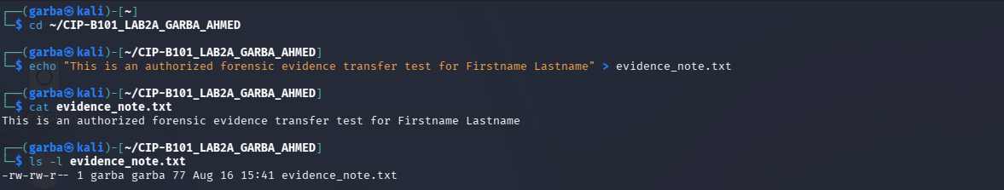
Task A2 (stdout Redirection): Redirected standard output of a directory listing into a log file using `>`:
cd ~/CIP-B101_LAB2A_GARBA_AHMED
ls -la evidence > logs/evidence_listing_stdout.txt
cat logs/evidence_listing_stdout.txt
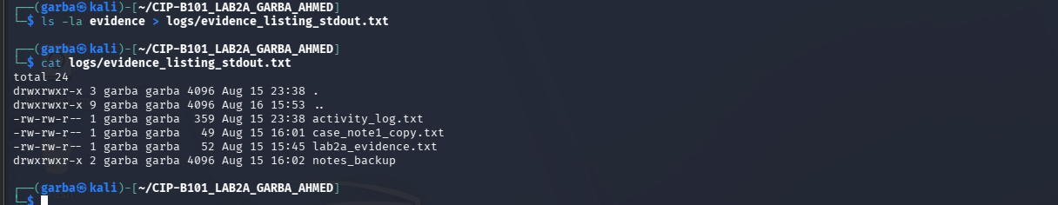
Task A3 (stderr Redirection): Captured standard error generated by attempting to read a non-existent file into an error log using file descriptor `2>`:
cat evidence/file_that_does_not_exist.txt 2> logs/error_stderr.txt
cat logs/error_stderr.txt
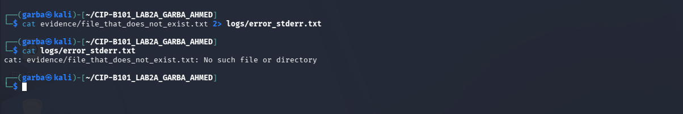
Task A4 (Combined Streams Redirection): Combined both `stdout` and `stderr` into a single log file using `> logs/combined_output.txt 2>&1:
(ls evidence && cat evidence/file_that_does_not_exist.txt) > logs/combined_output.txt 2>&1
cat logs/combined_output.txt
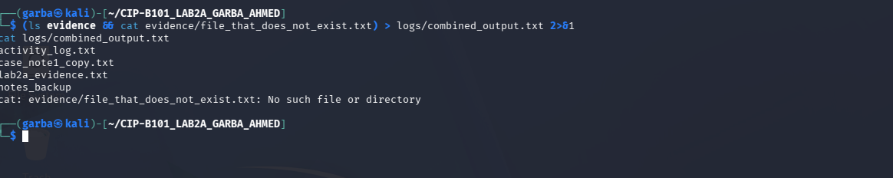
PART B: BASELINE SYSTEM AND NETWORK DOCUMENTATION
Task B1 & B2 (Host & Network Recording): Captured hostname, IP address configuration, routing tables, and netcat availability on both Linux and Windows environments:
hostname | tee logs/linux_hostname.txt
ip address | tee logs/linux_ip_address.txt
ip route | tee logs/linux_ip_route.txt
which nc || which ncat || echo "netcat or ncat not found" | tee logs/netcat_check.txt
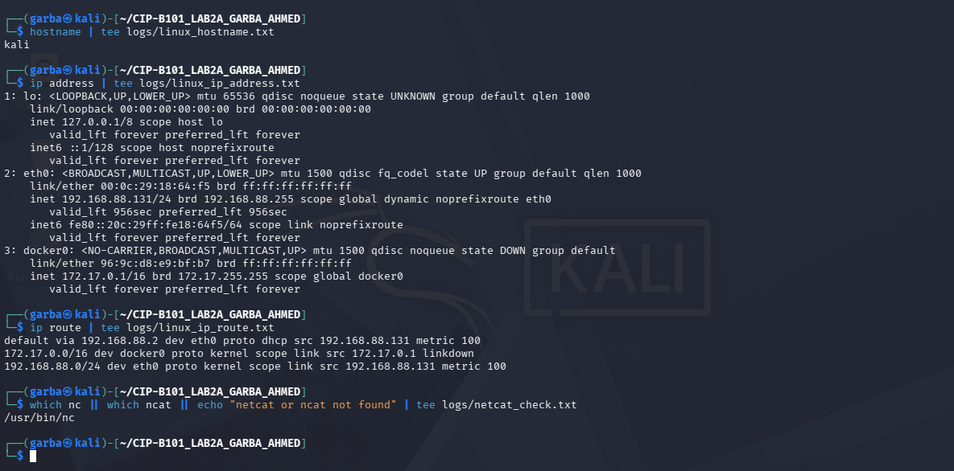
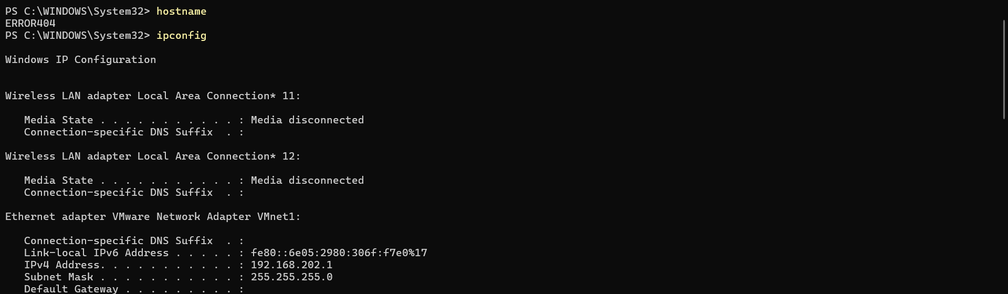
Task B3 (Connectivity Verification): Tested network reachability via bi-directional ICMP echo requests:
ping -c 4 192.168.202.1 | tee logs/ping_windows.txt
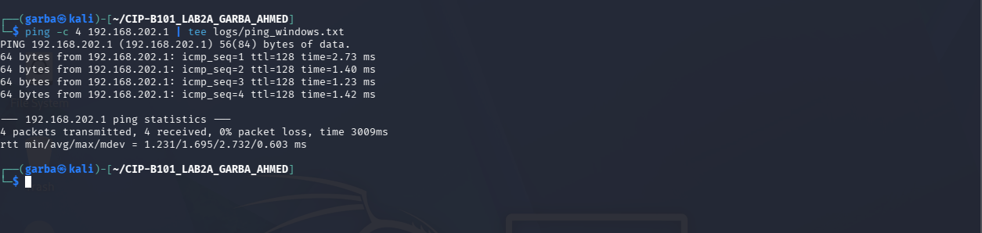
PART C: CROSS-PLATFORM EVIDENCE TRANSFER AND VERIFICATION
Windows Listener Setup: Configured a netcat listener on the Windows target to capture transmitted files and evidence notes on port 9090:
cd C:\CIP-B101_Lab2B_Received
"C:\Program Files (x86)\Nmap\ncat.exe" -l -p 9090 > received_evidence_note.txt
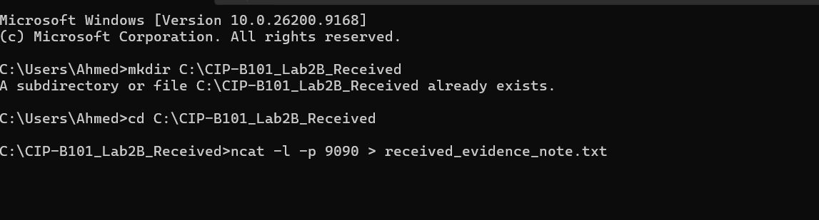
Windows-to-Linux Evidence Transmission: Created and verified a text file on the Windows side (GarbaAhmedEvidence.txt), computed its hash, and transmitted it to Kali Linux:
echo hello Garba Ahmed! > GarbaAhmedEvidence.txt
type GarbaAhmedEvidence.txt
certutil -hashfile GarbaAhmedEvidence.txt SHA256
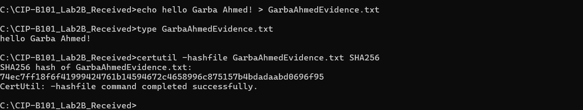
(Output SHA256 Hash: 74ec7ff18f6f41999424761b14594672c4658996c875157b4bdadaabd069 6f95`)
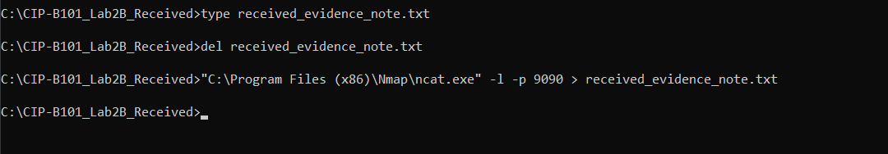
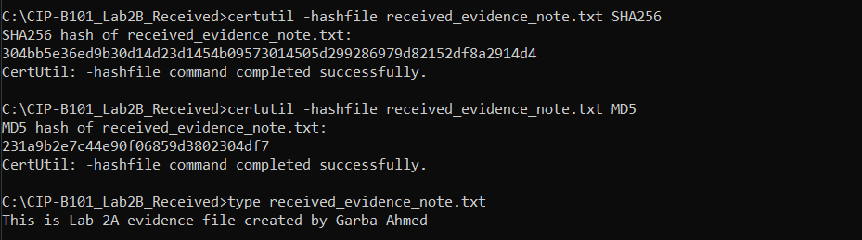
On the Kali Linux receiver end, the stream was captured, verified, and logged:
cd ~/CIP-B101_LAB2A_GARBA_AHMED/received
ncat -l -p 9091 > GarbaAhmedEvidence_received.txt
cat GarbaAhmedEvidence_received.txt
sha256sum GarbaAhmedEvidence_received.txt | tee ../hashes/received_windows_file_sha256.txt
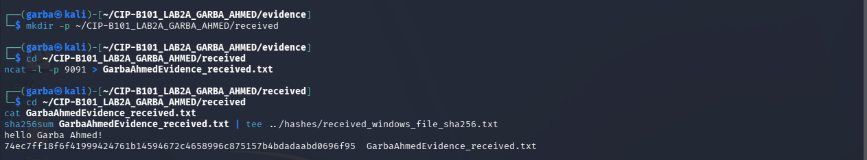
PART D: TEST IMAGE GENERATION AND TRANSFER
Image Creation on Kali Linux: Generated a controlled test evidence image using ‘dd’and populated a marker using echo:
cd ~/CIP-B101_LAB2A_GARBA_AHMED/evidence
dd if=/dev/zero of=test_evidence_image.dd bs=1M count=5 status=progress
echo "ICDFA test evidence marker - Garba Ahmed" | dd of=test_evidence_image.dd bs=1 seek=1024 conv=notrunc
ls -lh test_evidence_image.dd
sha256sum test_evidence_image.dd | tee ../hashes/source_test_image_sha256.txt
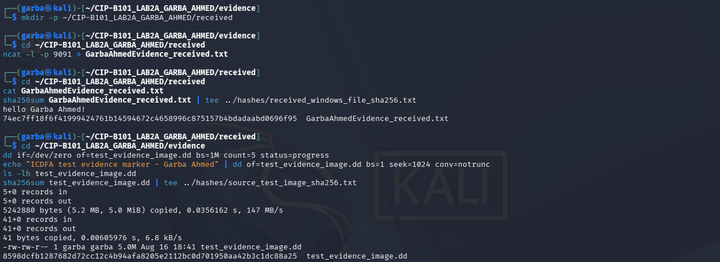
Image Transmission to Windows: Opened a listener on Windows port 9092 and piped the raw image stream from Kali Linux:
cd C:\CIP-B101_Lab2B_Received
"C:\Program Files (x86)\Nmap\ncat.exe" -l -p 9092 > test_evidence_image_received.dd
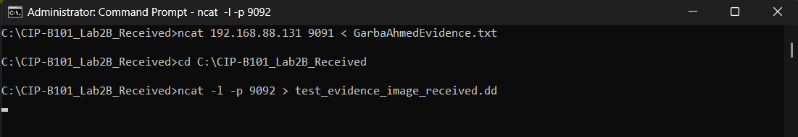
Corresponding transmission command executed from Kali Linux:
cd ~/CIP-B101_LAB2A_GARBA_AHMED/evidence
ncat 192.168.88.1 9092 < test_evidence_image.dd
Post-Transfer Windows Hash Verification: Verified the integrity of the received image file on the Windows target using `certutil`:
cd C:\CIP-B101_Lab2B_Received
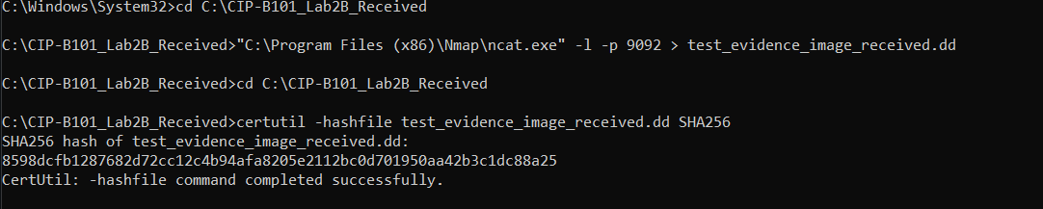
certutil -hashfile test_evidence_image_received.dd SHA256
(Output SHA256 Hash: 8598dcfb1287682d72cc12c4b94afa8205e2112bc0d701950aa42b3c1dc 88a25`)*
EVIDENCE INTEGRITY & HASH VERIFICATION RESULTS
Evidence Item / Operation | Source Hash (Pre-Transfer) | Destination Hash (Post-Transfer) | Status / Result
evidence_note.txt (Linux to Windows) | Local SHA256/MD5 recorded | Verified via Windows certutil | Verified Match
GarbaAhmedEvidence.txt (Windows to Linux) | 74ec7ff18f6f41999424761b14594672c4658996c875157b4bdadaabd0696f95 | 74ec7ff18f6f41999424761b14594672c4658996c875157b4bdadaabd0696f95 | Verified Match
test_evidence_image.dd (Kali Linux to Windows) | 8598dcfb1287682d72cc12c4b94afa8205e2112bc0d701950aa42b3c1dc88a25 | 8598dcfb1287682d72cc12c4b94afa8205e2112bc0d701950aa42b3c1dc88a25 | Verified Match

MOST SURPRISING FINDING
The most surprising aspect of this lab was observing how seamlessly raw byte streams can be piped across operating system boundaries over a network using a lightweight utility like `ncat`, while remaining entirely dependent on cryptographic hashes to prove authenticity. Without pre- and post-transfer hashes (`SHA256`/`MD5`), an investigator would have zero mathematical certainty that a file transmitted over a virtual network was free from subtle bit corruption, truncation, or silent manipulation. This emphasizes that network data transit in digital forensics is never taken on blind trust; integrity must always be mathematically proven.
RECOMMENDATION FOR FUTURE PROJECTS
Based on the lab findings, the following recommendations are proposed for future digital forensic workflows:
- Mandatory Cryptographic Hashing: Always compute and archive hash values immediately upon initial data acquisition and verify them again at every stage of transport or storage.
- Strict Network Segmentation: Perform remote acquisitions and file transfers exclusively over isolated, controlled virtual lab networks to eliminate external traffic interference or security risks.
- Authorized Tool Utilization: Restrict remote data piping to lightweight, auditable tools like ncat, strictly avoiding unauthenticated remote shell options or unauthorized backdoor execution vectors.
- Comprehensive Stream Logging: Systematically redirect standard output and error streams into dedicated log directories to ensure an immutable, reproducible audit trail of every forensic command executed.
- Pre-Testing with Small Images: Validate transmission protocols and block sizes using small test evidence images before attempting acquisitions on high-value production systems.

REFLECTION ANSWERS
1. What is the difference between standard output and standard error?
Standard output (`stdout`, file descriptor 1) handles regular, successful data streams generated by a command. Standard error (`stderr`, file descriptor 2) is a separate, dedicated channel reserved exclusively for diagnostic messages, warnings, and failure execution notes.
2. Why is command redirection useful during digital forensic documentation?
It allows investigators to automatically capture terminal outputs and execution logs directly into timestamped files, ensuring an accurate, objective, and tamper-resistant audit trail.
3. Why must a forensic examiner calculate the hash of a file before and after transfer?
Pre- and post-transfer hash comparisons provide mathematical proof that the digital evidence suffered no alteration, corruption, or truncation while traversing the network.
4. Why is it unsafe and unethical to use remote shell access on a system without authorization?
Unauthorized remote access breaches legal boundaries, violates user privacy, compromises system stability, and catastrophically destroys the legal chain of custody by introducing unverified environmental artifacts.
5. What is the difference between a bind shell and a reverse shell at a conceptual level?
A bind shell opens a listening port directly on the target machine waiting for an incoming administrative connection, whereas a reverse shell forces the target machine to actively initiate an outbound connection back to the examiner's listener (frequently utilized to bypass perimeter firewalls).
6. Why might a firewall block one type of connection but allow another?
Firewalls evaluate packets based on strict rules governing port numbers, traffic direction (inbound vs. outbound), stateful tracking, and protocol signatures. Unsolicited inbound connection attempts are typically dropped by default, whereas outbound or established flows are often permitted.
7. Why did this lab use a small test evidence image instead of imaging a real disk?
A small test image teaches the precise mechanics of bit-stream transfer, hashing, and stream redirection safely without risking live system instability, prolonged processing delays, or privacy violations inherent in full physical disk imaging.

CONCLUSION

This laboratory successfully demonstrated advanced Linux command-line text processing, stream redirection file descriptors, and secure cross-platform file acquisition techniques. By adhering strictly to authorized operational parameters and enforcing rigorous hash-based verification protocols, a reliable, repeatable workflow for digital evidence handling was established that satisfies professional forensic standards. Moving forward, integrating these structured logging and cryptographic verification practices will remain fundamental to maintaining absolute data integrity in all digital forensic investigations.

